**Document Change Request Approach**

**Module Description**

In this module, you will document the proposed schedule, budget and quality (stability, maintainability, etc.) for each Change Request solution option in the Change Request form. The team will then prepare for the meeting to discuss each Change Request with the Project Manager.

**Scenario**

You and the Team Lead will document the proposed solution for each change request. A meeting with the Project Manager will be scheduled and the meeting agenda prepared.

At the scheduled time, the appropriate team members will speak with the Project Manager about the following for each change request:

* The solution option defined by the team for each change request.
* The high level changes that will be made.
* Amount of time to complete the build and test.

The Project Manager will discuss with you and the Team Lead the approach proposed to address each change request for the client and provide some guidance and coaching (where needed).

You will take the feedback from the Project Manager and look into the impact in more detail (and make any required updates to the team’s solution). The Team Lead, with your assistance, will complete the Change Request with the proposed solution and estimate for the Change Committee (or Change Advisory Board).

**ADM Activity Context Diagram**

**High Level Context Diagram**

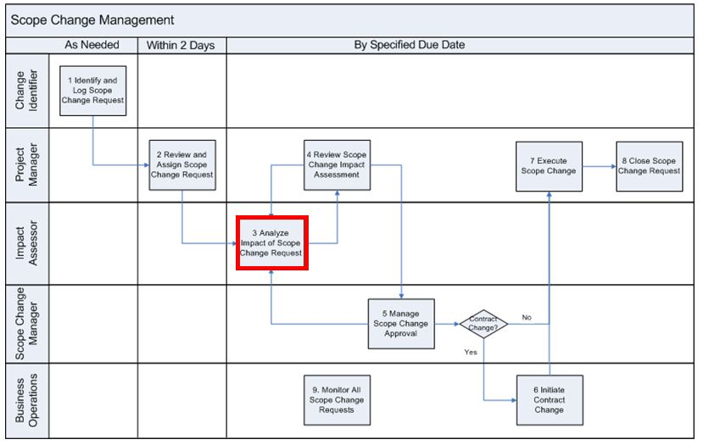

**Low Level Context Diagram**

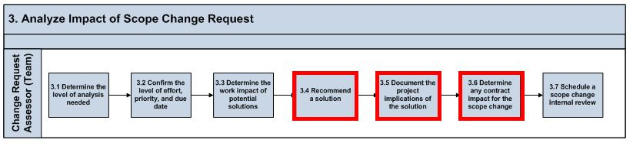

**Roles**

|  |  |  |  |
| --- | --- | --- | --- |
| **Role** | **ADM Task** | **ADM Responsibility** | **Description** |
| Project Manager | N/A | Management Oversight | Provides guidance on solution options for the Change Requests. |
| Team Lead | N/A | Primary Performer | Makes decisions on what solution option will be used for each Change Request and documents that solution.  Prepares for the meeting with the Project Manager and sends a meeting request. |
| Team (All) | N/A | Primary Performer | Prepares the final proposed solution option for each Change Request with estimate on completion.  Helps the Team Lead with preparing for the meeting with Project Manager. |

**Participant Instructions**

1. From the viable solution options considered, complete the following in the Change Request document (for each change request):

a. Select the best solution based on the data you have

b. Document the detailed analysis of that particular solution.

c. Specify your reasons for recommending that solution.

d. Associate that solution with affected requirements

2. Document the project implications of the solution in Part 3 of the Change Request and consider:

a. How many hours it will take?

b. How long it will take (in Workdays)?

c. The impact on the schedule (will this get done on time?)

d. The impact on resources (who will work on this? Who will work on the defects?)

3. Once the steps above are complete, you are ready to finish your activities by preparing for the meeting with the Project Manager. Review the Change Request Meeting Checklist below to prepare for the meeting.

4. Schedule with your manager an internal review and:

a. Determine who will be in the meeting from the team (the Team Lead is required to attend).

b. Send the Change Request to the Manager in advance.

**Change Request Meeting Checklist**

* Keep in mind that you may have to make changes to the Change Request approach document after the meeting with the Project Manager.
* Keep in mind other teams will need to meet with the Project Manager.
* Make sure you are prepared to effectively discuss the following:
  + Summarize the Change Requests for discussion.
  + Summarize the steps taken to review the Change Request impact.
  + The team's recommendation for each Change Request.
  + The idea/enhancements to address/resolve the issue.
  + Initial estimates on the enhancements.
  + What will happend if the enhancement is not implemented?

**Hints and Tips**

* When completing the change request, be sure to enter the effort calculations made back in Module 42, considering:
  + The number of team members involved in your team.
  + The amount of time spent on build and testing.
* Ensure you review your notes, or the slides, from the 'Productive Meetings' presentations so you are adequately prepared for this meeting.